A-3
COMMENTARY
LEARNING FOR LIFE
A drive to learn
Learning
- Not a one-time event
- Spiral curriculum
- Adding new competencies or adding new ones
What drives learning:
- Basic needs – Maslow – 5 levels

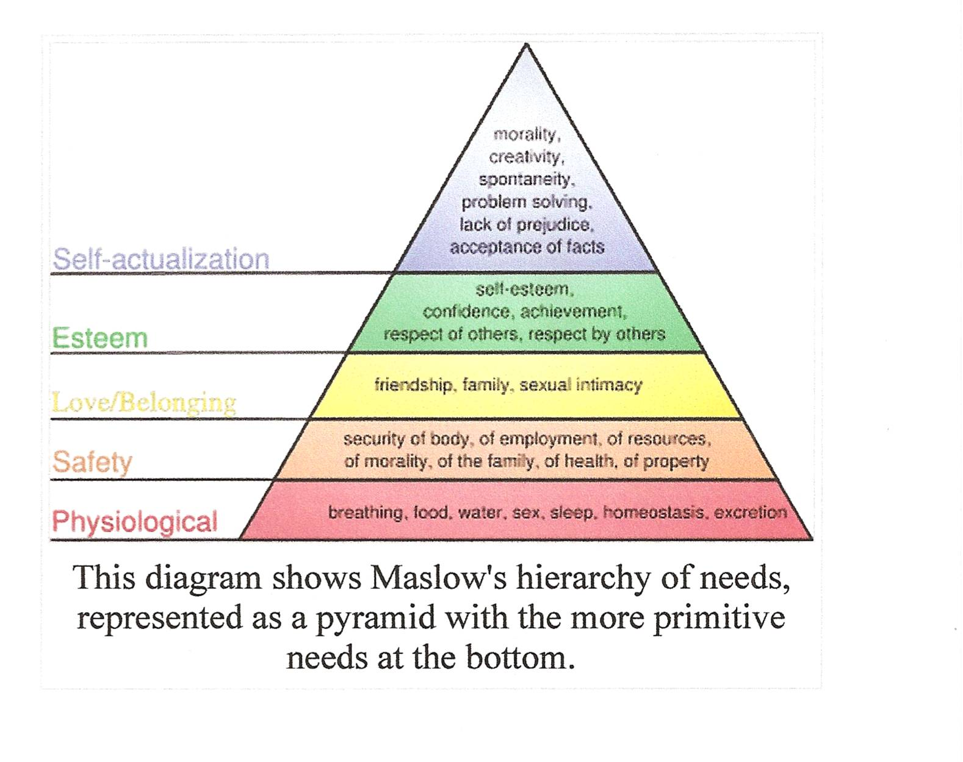
Real or imagined life roles - Oregon
- Individual
- Family Member
- Citizen
- Learner
- Consumer
- Producer

